TWIN VALLEY UNIFIED UNION

SCHOOL DISTRICT
BUDGET FY20
Budget Information 6:00PM
Annual Meeting 7:00PM
FEBRUARY 26, 2019 6:00PM
at TWIN VALLEY ELEMENTARY SCHOOL
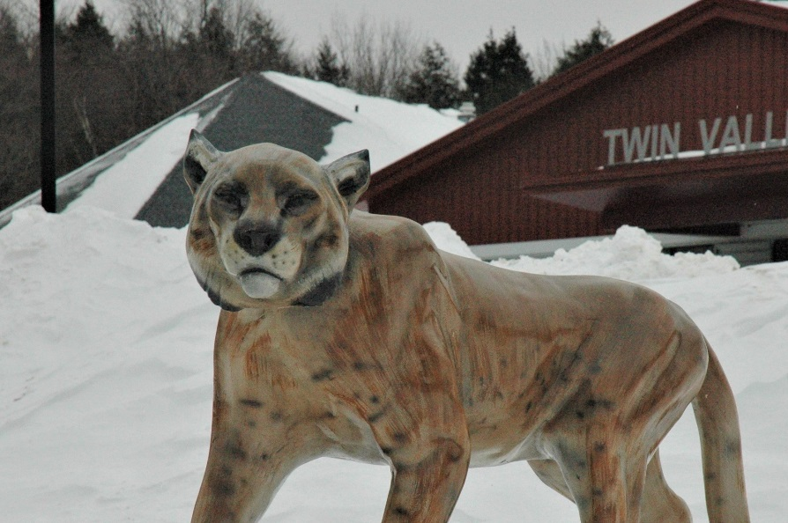
Vote by Australian Ballot at Town Meeting
March 5, 2019
Whitingham: Whitingham Municipal Center
10AM-7PM
Wilmington: Twin Valley Elementary
7AM-7PM

