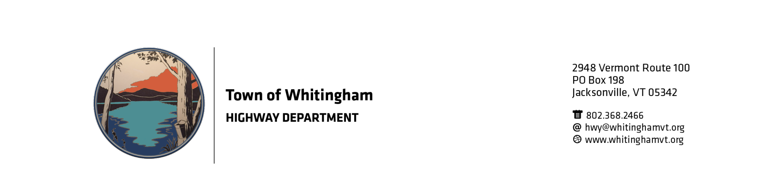

The Town of Whitingham is now accepting sealed bids for Full Depth Reclamation in the Town of Whitingham.

Project is located on Kentfield Road and Poverty Row which are continuous but will be done in two segments.

Project length is 9970’ X 22’ Approximately 24,400 sq. ft.

Traffic control will be provided by the Town of Whitingham

Calcium Chloride will be provided by the Town of Whitingham

Rolling and Grading will be done by the Town of Whitingham.

The Town of Whitingham has the right to reject any or all bids at any time or for any reason. Lowest bid does not automatically mean bid will be accepted. Prior performance, quality, professionalism, and ethics will be in the decision process.

Sealed Bids must be mailed or delivered to:
Town of Whitingham
Reclaim Bid
PO Box 198
2948 VT Route 100
Jacksonville, VT 05342

Bids will not be accepted after 2:00 pm on May 17, 2019. Bids will be opened at the regular Selectboard meeting on May 22, 2019 shortly after 6:30 pm.

For questions and to set up appointment to view the project please call Stanley Janovsky, Road Commissioner at (802) 368-2466 or email at whitinghampublicworks@yahoo.com.

