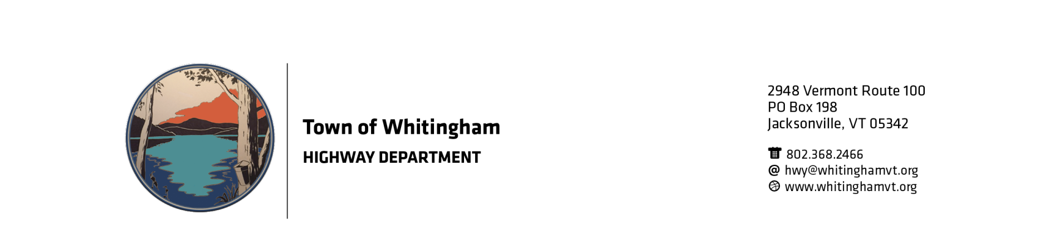

The Town of Whitingham is now accepting sealed bids for 1”- crushed gravel delivered to 4189 Rt 100, Whitingham, VT 05361. We are looking for approximately 2000 cubic yards.

Also, to bid is 1 ½” crushed stone delivered. Approximately 500 cubic yards.

The Town may request a sample of gravel before bid is signed by the Select Board.

Project start date is tentative anytime after July 1, 2019

Both the gravel and the stone will be by the cubic yard NOT PER TON!!

The Town of Whitingham has the right to reject any or all bids for any reason. If product quality isn’t acceptable after bid is signed, the Town of Whitingham has the right to reject product and payment at any time.

Lowest bidder may not receive winning bid.

Sealed Bids must be mailed or delivered to:
Town of Whitingham
Gravel Bid
PO Box 198
2948 VT Route 100
Jacksonville, VT 05342

Bids will not be accepted after 2:00pm on May 17, 2019. Bids will be opened at the regular Selectboard meeting on May 22, 2019 shortly after 6:30pm.

Contact Stanley Janovsky, Jr., Road Commissioner, at (802) 368-2466 or email whitinghampublicworks@yahoo.com

