Library Summer Camp
Monday’s 11 am – 3 pm
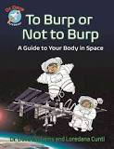
Ages 3-8 years
July 8th Title: Earth Spaceship
Craft: Spaceships and play-dough planet earth
Story: Pete the Cat: Out of this World by James Dean
GUEST: Serenity Circles: Hula Hoops and Bubbles

July 15th Title: Sun & Moon
Craft: Space Journals / Oreo cookie moon phases
Story: Brother Sun, Sister Moon by Katherine Patterson
GUEST: Teddy Bear Workshop: Stuffed Alien & Story
July 22rd Title: Mars & Mars Rover Exploration
Craft: Papier-mâché’ planets
Story: Mars Rover Rescue by Andrew Radar
GUEST: Taradiddle- Musicians’ and Storytellers’
July 29th Title: Constellations and their Myths
Craft: Constellation Tshirts
Story: A Hundred Billion Trillion Stars by Seth Fishmar
Movie: Muppets in Space
August 5th Title: Astronauts & Shooting Stars
Craft: Astronaut Helmut
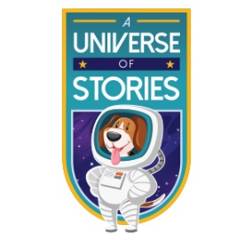
Stories: To Burp or Not to Burp: A Guided to
Your Body in Space
GUEST: Serenity Cicrles: Hula Hoops and Bubbles
August 13th Summer Party Woo!Hoo!

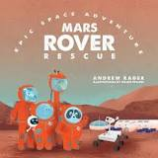

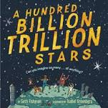

Daily Schedule
11:00 AM Arrival - Hello
Stories & Sharing with Kelso
(registered Pet Partner Therapy Dog)
Craft Projects
Lunch
Book/DVD selection for check-out
Outdoor Games & Exploration
Snack
Special Guest
3:00 PM Good-bye Pick-up
Registration is required to attend this program. Please call 368-7506.
(Children must be potty trained to attend.)

More space fun events on the back!

“Stories in the Park”
Story Hour at Town Hill
Saturdays 11:00 AM
June - September
Join us for stories & crafts
(rain location – library)
LIBRARY at WINGS CAMP
Sign-up through WINGS Community Programs http://www.wingscommunityprograms.com
Wednesday 17th 1pm
Mad Science Stage Show
(sponsored by Whitingham & Pettee Library)
“Destination Moon”
Experience a space vacuum, principles of flight, spinoff technology and even astronaut training. Like all Mad Science shows,
Destination: Moon is highly interactive and full of space-filling wow!
Thursday July 25th 1:30 pm
Summer Encore Theater
“The Sun, the Moon and the Stars”
Based on the Navajo myth of the origin of the sun, moon and stars. Summer Encore is a twenty year old program that involves students in grades 7-12 in developing and performing a play every summer.

