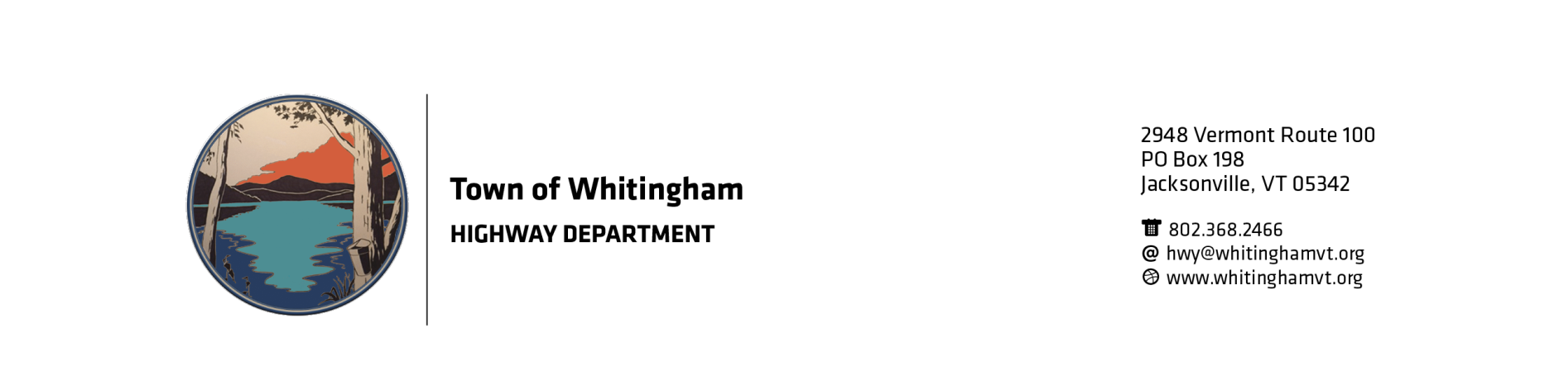
The Town of Whitingham is now accepting bids for 1” crushed stone to be delivered to 4189 Rt 100.

Sealed bid will be due no later then 2:00 pm May 17, 2019 and will be opened by the Select board shortly after 6:30 pm May 22, 2019 at the regular scheduled select board meeting.

Price will be for cubic yard.

Yardage will depend on winning bid price.

The Town of Whitingham has the right to reject any or all bids for any reason at any time.

For any questions please call
Stanley Janovsky Jr.

Road Commissioner

802 368 2466
whtinghampublicworks@yahoo.com

